Assignment 1 report

Part 1

fortune_teller.cpp

Part 2

A&B.

C. A floating point data type is judged to be unnecessary by the IEEE 754 because it does not serve as much of a purpose as a signed integer. It is also very time consuming to have to check if a floating point is signed or not for programs that uses many floats.

D. You could either change it to just float without signed or unsigned, or you could also check to see if the variable is negative and print out errors for it.

Part 3

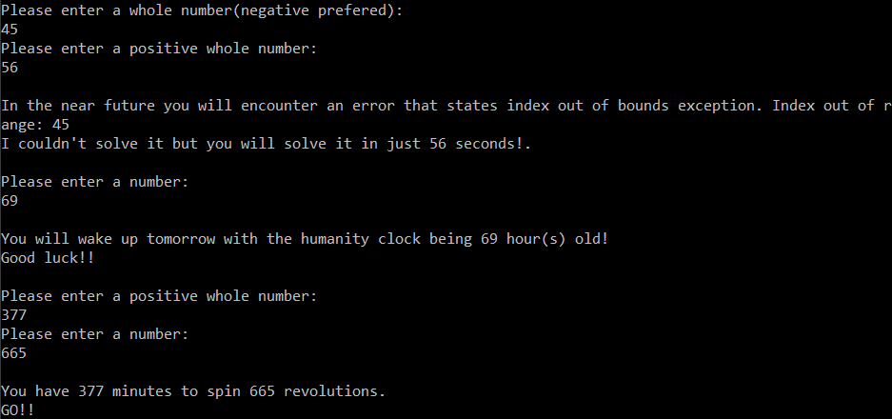

Another person: “it went smoothly and worked as expected .my number s were 45 ,56 69 ,377 and 665” what’s surprising – “surprising is that even before i typed in all the 5 number fortune started coming out”

Improvement: As an improvement, I believe I could set up a timer counting down the time for the last fortune while specifying a short preferable time span for the user to spin a preferable range of revolutions to make it more interesting.